
CONDITIONS OF SERVICE

Mahoney Law Group, APC (“Client”) agrees to the following Conditions of Service (“Agreement”):

TEMPORARY AND TEMPORARY-TO-HIRE SERVICES
- Howroyd-Wright Employment Agency, Inc. dba AppleOne Employment Services (“AppleOne”) employees are subject at all times to Client’s direct and indirect supervision while on assignment with Client; AppleOne does not supervise such employees on their assignments. Client further agrees that while AppleOne employees are on assignment with Client, they shall not be permitted, without express advance written approval by an officer of AppleOne, to i) engage in travel or otherwise operate a motor vehicle or any non-office machinery or equipment on behalf of Client, ii) handle cash or valuables or negotiable instruments (Client shall also not pay employees directly or advance any funds to them.), iii) be permitted unsupervised or uncontrolled access to confidential or proprietary information, including confidential access codes, iv) be permitted unsupervised access to or control of Client’s business premises, v) remove any property of Client from Client’s business premises, vi) purchase, consume or distribute any alcohol, or vii) consume drugs, unless advance written authorization is provided by a physician. Should any AppleOne employee be permitted to engage in any of the activities described in i)-vii) above, Client agrees to indemnify, defend and hold harmless AppleOne from claims arising therefrom and AppleOne shall have no liability or responsibility for losses resulting from the employee’s conduct.

- Background checks are available for an additional fee and must be agreed to in writing by AppleOne and Client. AppleOne shall have no liability in connection with the acts or omissions of third-party vendor(s) who perform any background check services.

- Client agrees to comply with all applicable state and federal laws, including, but not limited to, civil rights and employment-related laws. Client agrees to indemnify, defend and hold harmless AppleOne and its subsidiaries and related entities, and all of their respective officers, directors, shareholders, employees, agents, and representatives (collectively, “AppleOne Parties”) for claims, damages or penalties arising out of any violation of laws by Client. In addition, Client agrees to comply with all laws, regulations and ordinances relating to work site health and safety, and agrees to provide AppleOne employees a safe and healthful workplace. Client agrees to indemnify, defend and hold harmless AppleOne Parties for claims, damages or penalties arising out of Client’s violations of the Occupational Safety and Health Act of 1970, or any similar state law with respect to workplaces owned, leased or supervised by Client, and/or to which AppleOne employees are assigned. In the event of an accident, medical treatment, serious illness or injury, or death involving an AppleOne employee assigned to Client, Client shall notify AppleOne immediately. For any serious injury, illness or death, of an AppleOne employee occurring in a place of employment or in connection with an AppleOne employee’s assignment with Client, Client is required to report immediately, by telephone or fax, to the nearest Occupational Safety and Health Administration (“OSHA”) office and is authorized and required by AppleOne to make the report on behalf of both AppleOne and Client. Client shall provide to OSHA all information required by applicable law, as well as AppleOne’s name, address, phone number and contact person, and the AppleOne employee’s name. Client shall notify AppleOne immediately after the report has been made.

- Client will not reassign or relocate an AppleOne employee without prior written authorization by AppleOne. Client agrees to assume all liability for any third party claim arising after any reassignment or relocation that occurs without such authorization.

- Client understands that AppleOne employees are assigned to Client to render temporary service and, absent an agreement to the contrary, are not assigned to become employed by Client. Client acknowledges the considerable expense incurred by AppleOne to advertise, recruit, evaluate, train and quality control its employees. Client will not, without prior written authorization by AppleOne, hire an AppleOne employee, interfere with the employment relationship between AppleOne and its employee, or directly or indirectly cause an AppleOne employee to transfer to another temporary help service.

- Client understands that AppleOne may refer candidates for Client’s evaluation or assign AppleOne employees to render temporary services at Client often while such persons seek direct hire employment through AppleOne. If Client, either directly or indirectly, such as through any company within Client’s control, either solicits, offers employment to and/or hires any AppleOne candidate or employee as an employee or consultant in any position, or utilizes such person’s services through another temporary or outsourcing service, or any party affiliated with Client refers such person to any other employer and said person becomes employed by that employer: i) at any time from the date such person’s identity is provided by AppleOne to Client until six (6) months thereafter, or ii) within six (6) months after termination of such person’s temporary assignment through AppleOne at Client, whichever is the later, Client agrees to pay AppleOne a direct hire fee in accordance with AppleOne’s standard fee schedule stipulated by the parties to be equal to thirty percent (30%) of such person’s first year annualized wage or salary. Unless Client presents written evidence to AppleOne of Client’s prior knowledge of an AppleOne referred candidate i) within three (3) business days of AppleOne’s referral of such candidate to Client or ii) prior to Client’s interview of such candidate or iii) prior to AppleOne’s assignment of such candidate at Client, whichever is earliest, Client understands and agrees that Client is liable for the payment of any fees due to AppleOne pursuant to this Agreement.

- AppleOne offers temporary-to-hire services to Client. An AppleOne employee temporarily assigned to Client is an employee of AppleOne until released to Client. Should Client be interested in hiring an AppleOne employee, Client shall contact AppleOne, who will establish the terms and conditions for releasing the employee to Client’s payroll, including the conversion fee to be paid by Client if such terms are not otherwise agreed to between the parties. If any Client accounts are in default according to the payment terms in Section 9, Client shall bring the accounts current prior to the hiring. If Client hires an AppleOne employee with a Client account in default, Client agrees to pay AppleOne a conversion fee equivalent to the direct hire fee as set forth in Section 6 of this Agreement.

INVOICING AND PAYMENT
- Client understands that AppleOne employees must be paid weekly and agrees to promptly review, and approve or verify, timecards or hours worked. Client will be liable for any and all charges incurred based upon Client approved or verified timecards or hours or similar information submitted by Client to AppleOne. If timecards or hours lack timely Client approval or verification, AppleOne will process payroll and invoices based upon the timecards or hours submitted by the employees.

- AppleOne shall invoice Client weekly. Payment of invoices is due upon receipt. Client agrees that an account balance that remains unpaid thirty (30) days after the invoice date will be considered in default and that AppleOne may assess a default charge of one and one-half percent (1.5%) per month on any such balance. Client agrees to pay any such default charges and attorneys’ fees for the cost of collection.

- Client and AppleOne acknowledge that through the Patient Protection and Affordable Care Act of 2010, as amended (“ACA”), and regulations promulgated thereby, statutory requirements have been imposed upon certain employers of certain employees working in the United States. AppleOne is committed to fulfilling its ACA obligations through offering ACA-compliant benefits to eligible contingent workers, including AppleOne employees assigned to Client. In demonstrating Client’s commitment to ACA compliance, effective January 1, 2016, Client agrees to share in ACA-related costs by paying a $0.54 surcharge for each hour of service provided by each AppleOne employee assigned to Client. The surcharge will be billed to Client in a separate line item on the invoice.

- Client’s payment method (Check box.): ApplePay’s eCheck is the preferred method. ACH/Other shall be discussed between Client and the AppleOne representative.

- Additional agreed upon pricing for the services to Client under this Agreement may be set forth in one (1) or more exhibit(s) to this Agreement or as mutually agreed upon by the parties in writing. The parties agree that upon thirty (30) days’ written notice to Client, pricing under this Agreement may change to accommodate any increase or addition of any government-imposed taxes, fees or costs incurred by AppleOne after the Effective Date or an increase in the ACA surcharge. Client and AppleOne agree that such written notice may be in the form of an electronic communication, including email.

OTHER TERMS
- This Agreement supersedes any and all other agreements, either oral or written, between the parties or anyone acting on behalf of a party hereto, with respect to the subject matter hereof. This Agreement contains all of the covenants, conditions, warranties, representations, inducements, promises or agreements (oral, written, on a website, or otherwise) (“Promises”) between the parties with respect to the subject matter hereof. Each party hereto acknowledges that no Promises have been made by any party or anyone acting on behalf of any party which are not embodied herein and that no other Promises, which are not contained herein, shall be valid or binding. Any oral Promises or modifications concerning this Agreement shall be of no force or effect, except by a subsequent written amendment to this Agreement.

- The confidential and/or proprietary information of the disclosing party will be held in strict confidence by the receiving party and will not be disclosed by the receiving party to any third party, or used by the receiving party for its own purposes, except to the extent that such disclosure or use is necessary in the performance by the receiving party of its obligations under this Agreement. The receiving party upon the request of the disclosing party will destroy or return all writings or documents that contain information subject to the protections of this section.

- The laws of the State of California shall govern this Agreement, its interpretation and any disputes regarding the services. Any action concerning this Agreement or the services shall be instituted in the state or federal courts located in County of Los Angeles in the State of California, and AppleOne and Client agree to the exclusive personal jurisdiction of said courts and waive any rights to a change of venue. In the event that a party hereto commences any legal or equitable action or other proceeding, the prevailing party shall be entitled to recover reasonable attorneys’ fees in addition to any other relief.

- This Agreement shall be in effect from the last date set forth below (“Effective Date”) and shall continue until terminated at any time by either party in writing. Absence a prior agreement between the parties, services provided by AppleOne to Client before the Effective Date shall be considered as having been provided subject to the provisions of this Agreement. The rights and obligations in this Agreement which by their nature should survive will remain in full force and effect following the termination of this Agreement.

- In the event that any provision of this Agreement shall be unenforceable or inoperative as a matter of law, the remaining provisions shall remain in full force and effect.

- A waiver of a breach of any covenant, condition, or promise of this Agreement shall not be deemed a waiver of any succeeding breach of the same or any other covenant, condition, or promise of this Agreement. No waiver shall be deemed to have been given unless given in writing.

- The parties agree that this Agreement (and/or any of the Agreement’s mutually agreed upon ancillary exhibit(s) or document(s)) may be electronically signed. The parties agree that any electronic signature appearing on this Agreement (and/or such exhibit(s) or document(s)) is the same as a handwritten signature for the purposes of validity, enforceability and admissibility. Further, the exchange of this entire executed Agreement (and/or such exhibit(s) or document(s)) that is in photostatic or portable document format (.pdf) form by electronic mail or by another electronic means shall be considered original(s) and shall constitute effective execution and delivery of the original(s).

Client: Mahoney Law Group, APC Address: 249 E. Ocean Boulevard, Suite 814
Long Beach, California 90802

By (Please print.): ________________________ Title: ________________________

Signature: ______________________________ Date: ________________________

Howroyd-Wright Employment Agency, Inc. Address: 327 W Broadway, Glendale, CA 91204
dba AppleOne Employment Services

By (Please print.): ________________________ Title: ________________________

Signature: ______________________________ Date: ________________________

PLEASE SEND A SIGNED PHOTOSTATIC COPY OF THE AGREEMENT TO:

Denise Dancses AT EMAIL: ddancses@appleone.com

ApplePay’s eCheck Authorization Form
Please complete this form, sign and fax to (310) 750-1107
or email to ElectronicPayments@ain1.com.
You can also complete this form online at: www.applepay.com.

Company Name: |  | Customer No.:
Name on Account (if different from Company):
Address: | City, State, and Zip Code:
Phone Number: | E-mail Address (for invoice & receipt delivery):
(Customer Name) ________________________ authorizes All In One, Inc. dba ALL-IN-1, on behalf of Howroyd-Wright Employment Agency, Inc. dba AppleOne Employment Services, to electronically debit invoice payment(s) from the bank account referenced. A Preview of the current invoice(s) will be sent every Friday to the email address on file and the account will be electronically debited according to the payment terms. In the event that any payment is Returned from the financial institution, a notification will be emailed prior to the resubmission of the returned payment(s). It is understood and agreed upon that the original amount, in addition to a return item fee will be electronically debited from the bank account on file.

FOR All future invoices – please check box:
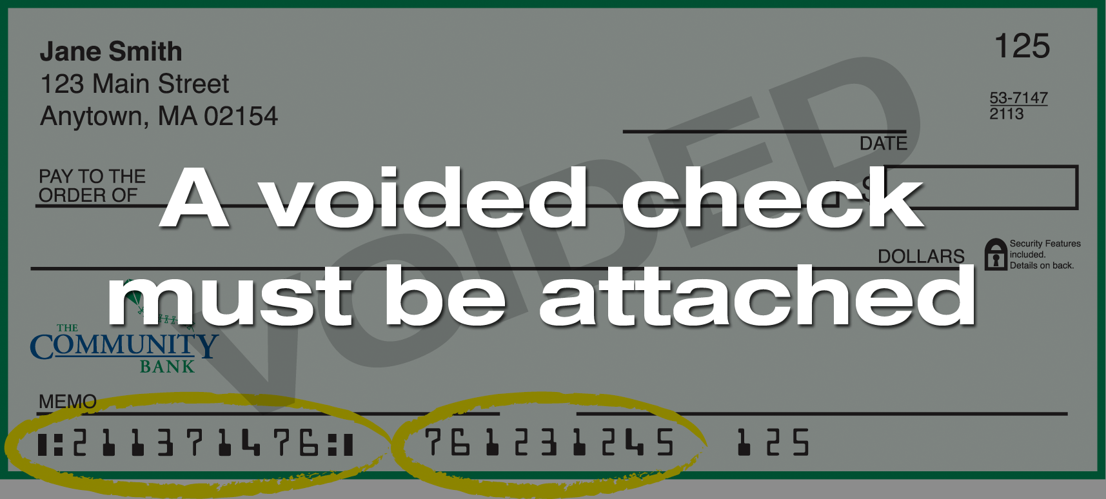

Invoice Number | Amount
 | $
 | $
 | $

Signature: |  | Date:
Print Name:
ALL-IN-1 · 1999 W. 190TH Street · Torrance, CA 90504 · Phone: (866) 898-7152

Director of Credit 06/20/2016

ApplePay is a registered trademark of Howroyd-Wright Employment Agency, Inc. dba AppleOne Employment Services.

